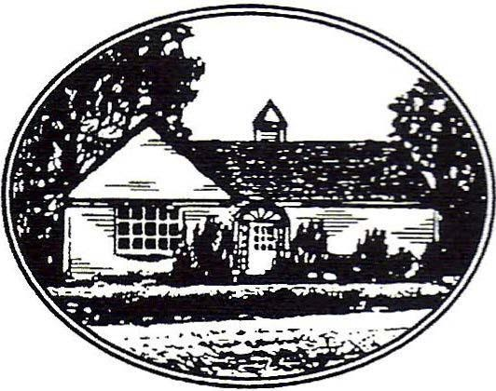
New Salem Public Library
23 South Main Street, New Salem, MA 01355
978-544-6334

New Salem Library Meeting Room Reservation Application

Name: _______________________________________ Phone: _________________________________
Email Address: ________________________________ Preferred contact: ____ email _____ phone
(check one)
Address: _____________________________________________________________________________
Reason for Use: ________________________________________________________________________
_____________________________________________________________________________________
Number of people expected: ____________
Date of Reservation: ___________________ Start time: _______________ End time: ________________
Additional comments: ___________________________________________________________________
AV Equipment: ________________________________________________________________________

I have read the New Salem Library Meeting Room Reservation Policy, and agree to its provisions.

Signature: ___________________________________________ Date: _______________________

Approval: ____________________________________________ Date: _______________________

Cleaning Deposit: ___________________________ Ck# or cash: ____________________________

Meeting Room Cleaning Checklist

Please complete form

- Name of Program: ______________________________________________________________
- Date: _________________________________
- Email address: __________________________________________________________________
- Number of people at the program: _______________
- Sweep floor, wipe down surfaces used and check window sills and book shelves for cups.
- Put recycling in bin and collect trash and take it with you.
- Turn off projector and fold up screen.
- Wash out sink if used.
- Turn off heat and lights.
- Lock doors.

