New Salem Public Library
Summer Reading Program 2022

Welcome to Summer Reading 2022! We are pleased that you will be joining us for 8 weeks of Summer Reading FUN! This year’s theme is “Read Beyond the Beaten Path, so our focus will be on lots of outdoor activities, nature, and really almost anything goes. We have reading logs and prizes for all ages, plus some programs throughout the summer.

Summer Reading Program 2022 in New Salem starts on June 25th with our kick-off celebration event: “Investigating Insects!” presented by The Hitchcock Center for the Environment. This program will be held Sat. 6/25 outside the library (weather permitting) from 10-11ish. The Summer Reading Program will end on Sat. 8/20 (with a celebration event to be finalized soon).

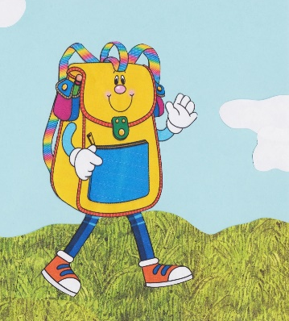
Traveling Backpacks: In the spirit of our theme, this year we are partnering with 9 libraries from the regional “Libraries in the Woods” group. Each participating library has created a unique Traveling Backpack full of some of the following: activities, things to read, tools for exploring, crafts to do and share, games to play, and more! Each week during the Summer Reading Program, there will be a different backpack traveling to New Salem from another library. Each week, you are encouraged to come and explore the visiting backpack, look through all the pockets, have fun with all the surprises, and then take an activity home with you to enjoy.

Weekly Programs: Each week we will have a Summer Reading Story Time with a different book and craft (and sometimes music). This program is geared to preschool – 2nd grade. [For a partial listing, see the back of this page.]

Prizes, Prizes, and More Prizes! This summer we have great prizes to help inspire you to meet your weekly reading goals. The “prizes” or “incentives” start when you register for the Summer Reading Program. In addition to your Reading Log with a “Registered” badge, you will receive a bookmark and your choice of a Summer Reading lanyard or bag. Each time you come to the library and log a book, you will get a “Smile” sticker to put on your log, and each time you have logged 5 books, you will get to add a Summer Reading badge to your log. At that time, you can also choose a small prize (pencil, sticker sheet, small book, etc.). Every reader will also get 5 raffle tickets to put in the raffle containers for the larger (end-of-the-summer) prizes. Come on in and join us for a summer of reading fun!

New Salem Public Library
23 S. Main St., New Salem, MA / 978-544-6334 / n_salem@cwmars.org
Website: newsalempubliclibrary.org / facebook.com/newsalempubliclibrary

